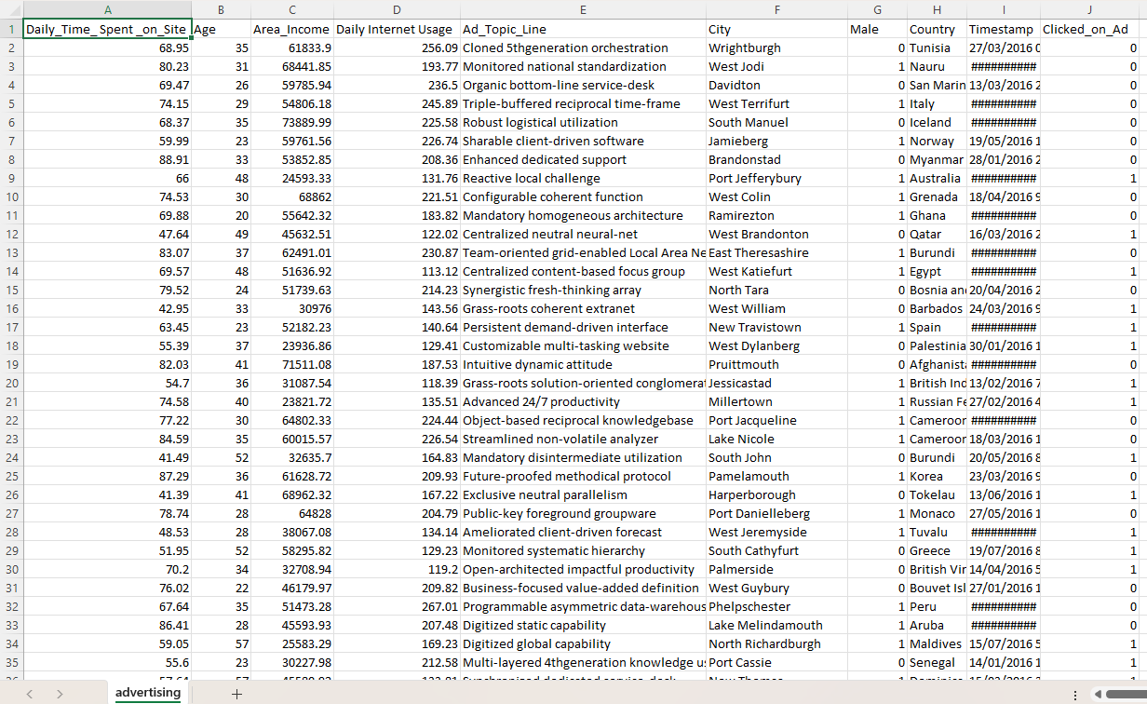
Name of Feature Description Type Relevance w.r.t other Features
1.Daily_Time_spent_on_site Time spent on site daily Quantitative, Continuous Relevant, inversely related to
clicks and interacts with
internet usage
2.Age Age of the User Quantitative, Numeric Relevant, correlates with
Gender and browsing habits
3.Area_Income Average income in the Quantitative, Continuous Relevant, affects purchase
Users Area behavior, related to ad
sensitivity
4.Daily_Internet_Usage Daily internet usage in Quantitative, Continuous Relevant, complements time
minutes on site for overall online
behavior
5.Ad_Topic_Line Ad topic shown to user Qualitative, Categorical Low relevance, but NLP helps
find sentiment/themes
6.City City of the User Qualitative, Categorical Irrelevant, too many city names
To be useful for patterns
7.Male Gender of the User Quantitative, Binary works well alone
(1=Male,0=Female) relevant, combines with age to
Influence ads
8.Country Country of the User Qualitative, Categorical slightly relevant, unless running
Global ads
9.Timestamp Date and Time of ad Display Quantitative, Time based Relevant, Become useful
After converting to features like
Hour, day, or month
10.clicked_on_Ad Target: whether the ad was Quantitative, Binary Target variable
clicked

